Accidental
poisoning

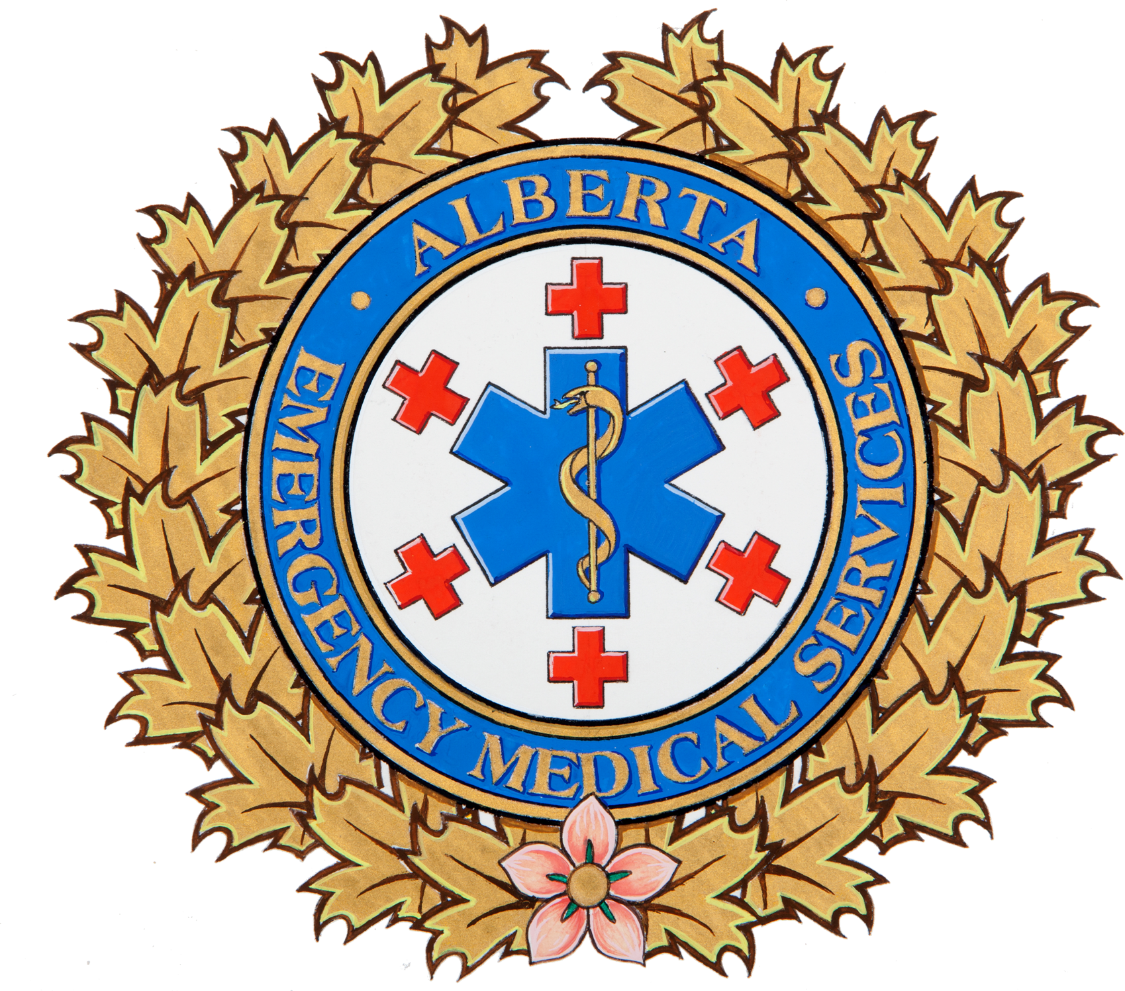

Alberta Health Services, EMS would like to remind parents of simple precautions to prevent accidental childhood poisonings around the home. Ingesting prescription or over-the-counter medications is the leading cause of accidental childhood poisonings. Other causes of poisoning include ingesting or coming in contact with house-hold items such as dishwasher tablets or mouthwash, or chemicals such as paints, solvents, and cleaning products.

Medication storage
- Place all medications in locked containers and store in an area inaccessible to children.
- For easy identification, store all medications in their original packaging; do not mix multiple medications in a single bottle.
- Install child locks on all cabinets, or drawers where medications are stored.

Prevention
- Store household products, cleaning supplies, and cosmetics in locked cabinets or drawers.
- Install child latches on cabinets children might also access by climbing on counters or chairs.
- Label all plants in and around your home and garden.
- Antifreeze, windshield washer fluid, and pesticides are extremely poisonous. Even small amounts of these can cause serious illness if ingested.
- Poisoning information can be obtained by calling the Poison and Drug Information Service (PADIS) at: 1-800-332-1414.
- In case of a poisoning emergency, call 9-1-1.
- Provide the name of the product ingested and, if it is safe to do so, a sample of the substance for EMS to inspect on their arrival.

Safety tips
- Child-resistant medication bottles are not child proof. They can still be opened by a child.
- Take extra precaution with medicines designed to appeal to children such as chewable vitamins or flavored cough and cold syrups.
- Promptly dispose of any medications or toxic household products no longer in use.

